

**UNIVERSITY OF MALAWI**

**THE POLYTECHNIC**

**FACULTY OF APPLIED SCIENCES**

**DEPARTMENT OF COMPUTING AND INFORMATION TECHNOLOGY**

**To: Dr. P A Chikumba**

**Module: GIS-401**

**Project Report for the Implementation of the Blantyre Tertiary Education Institutions (BTEI) Geographic Information System**

5th August 2019

**From**

**BIS Group 4**

Before Ndakwera [ BIS/13/PE/023]

Angella C Kamera [ BIS/14/NE/010]

Francis Ganya [ BIS/14/NE/004]

Abigail Mwale [ BIS/14/NE/026]

Table of Contents

Preface 4

Preamble 4

1.0 Concept Note 5

1.1 Area of study 5

1.2 Background 5

1.3 Problem Statement 5

1.4 Objectives 5

1.5 Study Questions 5

1.6 Justification of the study 5

2.0 Software Requirements Specification 6

2.1 Introduction 6

2.1.1 Conventions 6

2.1.2 Glossary 6

2.1.3 Intended Audience and Reading Suggestions 6

2.1.4 Project Scope 6

2.1.5 References 6

2.2 Overall Description 7

2.2.1 System perspective 7

2.2.2 System Features 7

2.2.3 System Architecture 7

2.2.4 User Characteristics 9

2.2.5 Operating Environment 9

2.2.6 Design and Implementation Constraints 9

2.2.7 User Documentation 9

2.2.8 Assumptions and Dependencies 10

2.3 Specific Requirements 10

2.3.1 Functional Requirements 10

2.3.2 Non-Functional Requirements 11

2.4 System Models 12

3.0 Data Collection 13

3.1 Introduction 13

3.2 Data Collection Workflow 13

3.2.1 Planning 13

3.2.2 Resources 13

3.2.3 Target Institutions 14

3.2.4 Data Collection Responsibility assignments 15

3.2.5 Scheduling 16

3.3 Preparation 16

3.3.1 Attributes Data 17

3.4 Digitizing / Transfer 18

3.5 Editing and Improvement 18

3.6 Evaluation 19

3.7 Data collection challenges 19

4.0 Application and Models 20

4.1 Map Design 20

4.2 Technologies 21

ArcGIS 21

QGIS 21

Leaflet 21

4.3 Technology Limitations 21

4.4 Spatial Analysis 21

Central Feature 22

Mean Center 22

Standard Distance 22

Directional Distribution 22

4.4 Application Screenshots 22

5.0 Team Members Individual Reflections 26

Francis Ganya 26

Abigail Mwale 26

Angella Kamera 26

Before Ndakwera 27

6.0 Conclusion 27

# Preface

Geographic information systems (GIS) are computer-based systems which store, manipulate, analyses spatially linked data and displays summary information on a map. Such systems are composed of people, data, procedures and technology to support communication and decision making.

In Malawi, it is the current norm for students to pursue and attain an academic qualification higher than the regular Malawi School Certificate of education (MSCE). Students and parents look for information on available colleges and training institutions together with relevant information on what they are offering that is: courses and approximate fees and possibly academic calendars.

Unfortunately, such information is not readily available and acquisition of such information is expensive. Potential students together with their parents incur costs to travel around to acquire this information. This is more expensive since these students want to compare available options hence they have to make visits to several institutions across the area. Furthermore, acquisition of information puts an extra overhead on time which would have been used for other productive work.

# Preamble

This document is a report of the activities and outcome of a GIS project to map tertiary education and training institutions in the city of Blantyre. This project was undertaken by a team of final year students in B.Sc. in Management Information Systems. It was a 4-man project and presented is the work that was performed, outcome and experiences.

The first section is the concept note that was presented as a proposal for the initiation of the project. Section 2 presents the initial software requirements specification. Section 3 is a data collection sub-report. Section 4 consists of the screenshots of the application and its models together with associated technologies that were used and a discussion of the technological issues that influenced a change in some of the initial requirements. The document concludes with the student’s individual reflections on the project.

Note should be taken that the term BTEI and BHEI are used interchangeably throughout the document and that they refer to the same system.

**Section 1: Concept Note**

# Concept Note

This section presents an embedded copy of the initial concept note that drove the undertaking of this project. It presents an area of study, the background, problem statement, objective, study questions and a justification of the project.

## 1.1 Area of study

Mapping of tertiary education institutions in Blantyre (Private and public colleges)

## 1.2 Background

It is the current norm for students to pursue and attain an academic qualification higher than the regular Malawi School Certificate of education (MSCE). Students and parents look for information on available colleges together with relevant information on what they are offering that is: courses and approximate fees and possibly academic calendars.

## 1.3 Problem Statement

The challenge is that this information is not readily available and acquisition of such information is expensive. Potential students together with their parents incur costs to travel around to acquire this information. This is more expensive since these students want to compare available options hence they have to make travelling’s to several institutions across the city. Furthermore, acquisition of information puts an extra overhead on time which would have been used for other productive work.

## 1.4 Objectives

To review available geo-visualization tools that map out human social facilities. Furthermore. this assignment will seek to develop a geo-visualization tool that maps out tertiary academic institutions available in Blantyre.

## 1.5 Study Questions

* Will availability of the geo-visualization to improve information access about academic institutions in Blantyre.
* Can the availability of such a geo-visualization tool reduce costs overheads for both time and money?
* Can regular individuals adopt geo-visualization tools and embrace their usefulness.

## 1.6 Justification of the study

The review of available geo-visualization tools will equip the students with more knowledge on the implementation, functionality and utilization of geographic information systems. Furthermore, it will enable the students to have a hand-on experience on the implementation of geographic information systems.

**Section 2: Software Requirements Specification**

# 2.0 Software Requirements Specification

This section seeks to present the software requirement specification for the BHEI GIS. It defines and describe the software requirement specifications for the Blantyre TertiaryEducation Institutions geographic information system. This is the first and only version of the requirements document for this system.

## 2.1 Introduction

### 2.1.1 Conventions

This SRS section uses the conventions that have been outlined below and otherwise specifically stated in the document, the reader should use these conventions to understand the contents.

* Special terms and content that user should pay attention have been emphasized by bold font

### 2.1.2 Glossary

|  |  |
| --- | --- |
| DB | Database |
| GIS | Geographic Information System |
| BTEI GIS | Blantyre Tertiary Education Institutions GIS |
| Geo-Database | Geographic Database |
| GiB | Gigabyte |
| RAM | Random Access Memory |

### 2.1.3 Intended Audience and Reading Suggestions

This document is primarily intended for the **college lecturer** responsible for assessing the system prototype and generally any individual seeking to understand the system for the purpose of public use, development maintenance, testing and documentation.

* Section 2 of this document presents an overview description of the system and references.
* Section 3 discusses the specific functional requirements and non-functional requirements of the system.
* Section 4 illustrates the system models to of the system.

### 2.1.4 Project Scope

The BTEI GIS will be a prototype information system which will collect spatial data of tertiary education institutions and skills development institution in the city of Blantyre.

### 2.1.5 References

Longley, P. A., Goodchild, M. F., Maguire, D. J., & Rhind, D. W. (n.d.). *Geographical Information Systems and Science* (2nd Edition ed.).

## 2.2 Overall Description

This section of the document describes in brief all the general details of the system and its requirements.

### 2.2.1 System perspective

BTEI GIS will be a geographic information system that stores information of tertiary education institutions and skills development institutions in Blantyre. It will be accessible over the internet and will provide services to the public. It will store the following significant information that is needed by potential students and individuals seeking to enroll in academic and training institutions:

* **Institution location**

The system will store geo coordinates of the institution that will be used to map the institution to provide travel directions.

* **Fees details**

The system will provide approximate fees structure details for the programs that are offered by the institution.

* **Contact details**

The system will provide the institutions contact details including telephone numbers, email addresses and postal addresses.

* **Training areas**

The system will store and provide training areas which are covered by the programs that the institutions provide for instance commerce, engineering, computer science and architecture.

### 2.2.2 System Features

The BTEI GIS will have mainly two components. A navigation helper and an information helper.

#### 2.2.2.1 Navigation Helper (Tools)

This system feature will allow a user to get the location of the institutions and provide directional guidance on how to reach the destination if the spatial information that will be provided will not be enough. This feature will allow the user to see important details such as distance so they can make informed decision on the optimal institution to attend.

#### 2.2.2.2 Information Helper (Tools)

This is the main system feature that will provide information to the user. This feature will enable the user to view important details about the institutions including all the spatial attributes: contact details like phone and email, postal address, physical locations and program areas that are being offered by the institution.

### 2.2.3 System Architecture

The BTEI GIS will use a societal implementation and will be accessible via the internet. As such this system will use the classical client-server GIS software architecture where by the system will have hosted on a web server and clients will make request to be processed by the server. The diagram below illustrates the architecture that the BTEI GIS system will use:

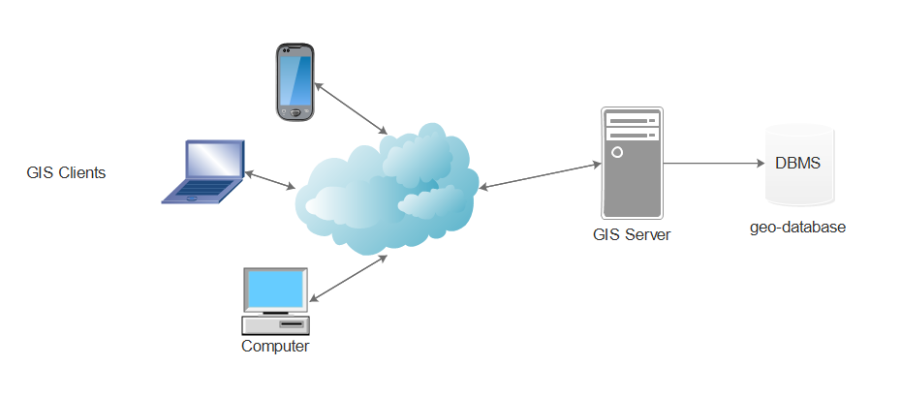

Figure 1 GIS application architecture

For optimal performance the client device should have the following specifications

|  |  |
| --- | --- |
| **Specification** | **Minimum** |
| Screen Size | 360 x 400 pixels |
| RAM | 1 GiB |
| Internet Connectivity | YES |
| Hard Drive | N/A (user will not be required to store any local data) |

The GIS server computer will have need to have the following specifications

|  |  |
| --- | --- |
| **Specification** | **Minimum** |
| RAM | 2 GiB |
| Operating System | Linux Server OS |
| Internet Connectivity | YES |
| Hard Drive | 10 GiB |

### 2.2.4 User Characteristics

The system is primarily developed to be used in the public domain by school leavers and individuals seeking to analyze the distribution of education institutions and skills development centers in Blantyre. Thus, the system has 3 intended users

* Public citizen

This user will be able view locations and details of the institutions catered by the system. They will be able to get direction, contact details, fee structures and program areas offered.

* Geo spatial Professional

This user will be able to access everything that the standard citizen will be able to access in addition to the actual exports of the collected data

* Administrators

This user will be able to access everything including functionality to update the geo database data.

### 2.2.5 Operating Environment

Every system operates in a specific environment. This section outlines the environment specifications for the functional operation of the BTEI GIS Software.

The System will run in a web browser as such the client devices will only require reasonable computing resources.

See appendix for specific device requirements.

### 2.2.6 Design and Implementation Constraints

The BTEI GIS software will be a prototype system and has several implementation constraints

* The system will be developed by undergraduate students as such full functionality is not guaranteed due to lack of expertise.
* Resources to fully develop and deploy the system are limited as they require other financial resources currently not available.
* Programming of the system will require time which does not tally with the time frame allocated for the project.
* To be fully deployed the system will require to be reviewed by professionals which again might take time more than what is allocated for the project.

### 2.2.7 User Documentation

The BTEI GIS will provide the following user documentation

* Introductory Tutorials and
* User manual for maintaining the geo database

### 2.2.8 Assumptions and Dependencies

This sub section outlines the assumptions on which the system will operate on and its dependencies/

**Assumptions**:

* The user has basic computer skills and know how to operate a computer.
* The user has basic knowledge of geographical maps and can read basic details on a map.
* The user resides in Blantyre or intends on attending an education institution or skills development center in Blantyre.
* The user has access to a device with a compatible browser to access the system.
* The user has an active internet connection to access the system

**Dependencies**:

* The system shall utilize shape files from MASDAP to visualize the geo data on a map

## 2.3 Specific Requirements

This section of the document discusses the BTEI GIS system requirements in detail covering functional and non-functional requirements, system models, design constraints, assumptions, Software system attributes and other requirements.

### 2.3.1 Functional Requirements

User requirements gathering was conducted through the channels of observation and review. Initially similar software products were reviewed and tested as to what they offer and evaluated. Afterwards the development team observed the need for an automated Geographic information system that provides education data at the tip of their fingers. The process for information acquisition was carefully brainstormed and the following user requirements were drawn to develop a GIS that addresses the noted issues:

* The system shall allow the user to see a list of all available tertiary education institutions and skills development centers in the city of Blantyre
* The system shall allow the user to view a mapping of all the catered education institutions and skills development centers in the city of Blantyre
* The system shall allow the user to see the location and directions of how they can get to a specific catered education institution or skills development center.
* The system shall provide the user with specific contact details of a chosen education institution or skills development center catered by the system.
* The system shall allow the user to view the approximate fee amount of a chosen education institution or skills development center catered by the system
* The system shall allow user should be able to view the training areas that a chosen education institution or skills development center is offering such as commerce, computer science and engineering.

### 2.3.2 Non-Functional Requirements

Non-functional requirements are requirements that define the non-operational attributes of the system that have nothing to do with the system’s main functions. This sub-section of the requirements section discusses the non-functional requirements of the BTEI GIS software.

#### 2.2.2.1 Performance

The system will be web based and for optimal performance the system must operate shall operate under the following performance constraints

* Initial program load independent of internet connection must not exceed more than a reasonable 3 minutes
* The memory requirements and processing requirements for the system must cater for low resource devices such as mobile phones

#### 2.3.2.2 Reliability and Availability

The system shall meet the following reliability and availability constraints

* The system shall be available for users 24/7
* The system shall provide up to date information to support accurate decision making

#### 2.3.2.3 Usability

The system shall meet the following usability requirements to enhance the user experience

* The system shall have a consistent look across all screens of the system
* The system should provide a visual direction for chosen locations
* The system shall make heavy use of graphical elements to enhance usability
* The system shall require only basic computer skills and geographical skills to use it
* The system should provide a user interface that is compatible with standard browsers such as Google Chrome, Mozilla Firefox and Microsoft Internet Explorer.

#### 2.3.2.4 Security

The system shall conform to the following security requirements

* Access to the geo database shall only be permitted only to authorized system administrators
* System administrators will be required to provide a username and password which will conform to standard secure password requirements
* No unauthorized edits to the data in the geo database will be permitted
* User searches and system use will not be tracked without permission to enhance privacy

## 2.4 System Models

This section presents applicable system models to illustrate its functionalities. 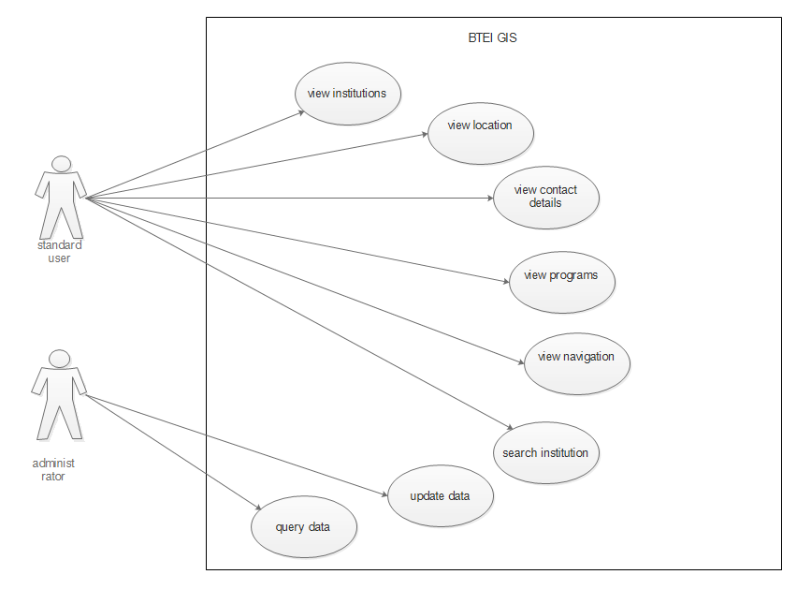

Figure 2 GIS application use cases

**Section 3: Data Collection**

# 3.0 Data Collection

## 3.1 Introduction

Data is an essential element of any geographic information system. The main importance of geographic information systems is to support communication and decision support tools which all rely on availability of high quality and accurate spatial data. This makes the data collection process for a GIS application an important and crucial task to the success of the system. However, this process is time consuming and expensive as it has to be carefully done to provide high quality data. Essential data has to be collected using different methods and in different formats including raster and vector.

This section seeks to present a detailed report of the data collection process for the Blantyre Tertiary Education Institutions (**BTEI**) geographic information system (**GIS**).

## 3.2 Data Collection Workflow

This section presents a detailed workflow of the tasks that were carried out during the collection of the geo-spatial data for the BTEI GIS software. Like most GIS software systems, data collection process for the BTEI GIS followed the standard routine phases which are discussed in detail.

### 3.2.1 Planning

This was the initial phase in the project whereby the development team identified the problem that is to be solved by the BTEI GIS software. Necessary observations were made, ideas were devised and eventually the development team came up with user requirements definition. During this stage the team identified resources that were to be used in the development of the system.

The software requirements specification document was developed and can be obtained from any member of the development team.

### 3.2.2 Resources

The resources to be used in the development were devised and are as outlined below:

* Human Resources
* Hardware Resources
* Software Resources
* Financial resources

#### 3.2.2.1 Human Resources

This category of resources was made up by members of the development team namely:

* Angella Kamera
* Abigail Mwale
* Francis Ganya
* Before Ndakwera

All tasks were shared equally and the team members collaboratively worked together to gather and organize the spatial data that was collected as the work breakdown illustrates.

#### 3.2.2.2 Hardware Resources

For certain spatial data the team had to physically travel to the locations of interest to collect coordinates and other spatial attributes. The team used mobile phone devices fitted with GPS modules to acquire the coordinates.

#### 3.2.2.3 Software Resources

The GPS hardware module embedded in the mobile device was not of use alone. It had to be used together with other mobile geographic information systems on an android device and windows office tools specifically

* **Google Maps**
* **GPS Coordinates**
* **Microsoft Office Word**
* **Microsoft Office Excel**

#### 3.2.2.4 Financial Resources

The development team required internet connectivity to research and use the software applications but also required transport to travel to the several locations whose data required physical collection. As such a certain amount of financial resources were required and contributions were made.

### 3.2.3 Target Institutions

A preliminary research was carried out and target institutions to be included in the BTEI GIS were identified as listed:

* The University of Malawi, the Polytechnic
* The Polytechnic Management Development center
* The Polytechnic Continuing Education center
* National College of Information Technology (NACIT)
* Malawi College of accountancy (MCA)
* Blantyre international university (BIU)
* Sanwecka
* College of medicine
* Health Science
* Kamuzu college of nursing
* Skyway
* Malawi institute of tourism
* Malawi Institute of management
* PACT
* Soche Technical College
* Blantyre Teachers College (Soche TTC)
* Kings and Angels – school of designs and tailoring
* Beehive
* LUANAR
* MIJ

### 3.2.4 Data Collection Responsibility assignments

After identification of the institutions to acquire data on, each member was given target institutions for which they were responsible for as outlined:

**Collectively by All**

* The University of Malawi, the Polytechnic
* The Polytechnic Management Development Center
* The Polytechnic Continuing Education Center
* Malawi College of accountancy

**Francis Ganya**

* Blantyre international university
* Kamuzu college of nursing
* Beehive
* LUANAR ODL

**Abigail Mwale**

* Malawi Institute of management
* PACT
* Soche Technical college
* Blantyre Teachers college (Soche TTC)
* National College of Information Technology

**Angella Kamera**

* New horizon
* Western college
* Malawi institute of tourism
* Skyway
* MIJ

**Before Gavinala**

* Kings and Angels – school of designs and tailoring
* Sanwecka
* College of medicine
* Health Science

### 3.2.5 Scheduling

Following the identification of target institutions and allocation of responsibilities, a schedule of tasks was devised. A list of tasks to be completed was formulated and tallied with team members who were primarily responsible for seeing to it that it was achieved. The table below shows the activities against the team members who were responsible for its completions.

|  |  |  |
| --- | --- | --- |
| Activity | Members | Current Status / Comment |
| Collection Software Installation | Francis Ganya and Before Ndakwera | Software applications were downloaded and installed / Successfully completed |
| Acquisition of finances | All team members | All required funds were collected and internet connectivity was purchased / Successfully completed |
| Training on software use | All team members | All team members were acquainted with the use of the software / Successfully completed |
| Physical Data collection | All team members focusing on their allocated institutions | Team members collected coordinates and spatial data for their assigned institutions /Successfully completed |
| Data entry | Abigail Mwale and Angella Kamera | All collected data was consolidated into a single excel base for further processing / Successfully completed |

## 3.3 Preparation

Following the acquisition of all necessary resources, the necessary software was installed on the computer laptops and android mobile phones of all team members. Afterwards the team members collected the GPS coordinates and data attributes for each of the assigned institution. Below are excel imports of the data that was collected.



### 3.3.1 Attributes Data

The follow attributes for the target institution was collected from various sources including application documents and institutional websites.

* Phone number
* Email
* Postal address
* Location
* Approximate fees
* Programs



The full details of the attributes can be viewed from this attached [file geo-data.xlsx](geo-data%20final.xlsx)

## 3.4 Digitizing / Transfer

The team used both the secondary data capture and data transfer secondary methods to acquire the GIS data. A majority of the coordinates were obtained on the desk using the google maps and 3 locations had to be physically visited to capture the data as they were not available on google maps. These institutions are namely:

* Skyway
* Sanwecka
* Kings and Angels

Data from both secondary sources was consolidated in the attached excel spreadsheet document coupled with the attributes. Shapefiles of other layers were obtained from the class lecturer.

## 3.5 Editing and Improvement

Taking seriously the importance of having accurate data, the team devised a checklist of data validation tasks that had to be undertaken to ensure consistency, accuracy and completeness.

The development team ensured accuracy by double verifying the GPS coordinates. This was achieved by comparing coordinates retrieved from the 2 GIS systems: Google maps and GPS coordinates. Furthermore, accuracy checks were done by peer review of coordinates collected by team mates.

The whole team collectively verified completeness of the attribute data through consolidation of missing attributes. Data recording was standardized and formatted with a consistent format.

## 3.6 Evaluation

Finally, the team collectively conducted an evaluation of the projects data collection progress with what was initially planned. It was agreed and concluded that all the items on the project plan were completed and the data collected was of high quality thus it passed the completeness, accuracy and consistency checks that it was subjected to.

The next stage was to construct the geo database structure and populate the collected data to finally map and implement the BTEI GIS.

## 3.7 Data collection challenges

The main limitations that were encountered in the process of data collection are outlines below:

* Due to the unavailability of a GPS device the team used to their mobile phone to collect coordinates and this to some extent was a major source of errors. For instance, some institutions were mapped incorrectly and the team had to recollect data for those institutions.
* The team did not have adequate knowledge on coordinate systems and ignorantly collected the coordinates without knowledge of the coordinate system. This presented challenge when the data was being integrated to be overlaid on other layers using a different coordinate system.

**Section 4: Application and Models**

# 4.0 Application and Models

## 4.1 Map Design

After the collection of spatial data, the GIS team went on to design and develop the map of the institutions. The collected data was recorded in an excel document with proper naming conventions for field names.

Once the excel data was prepared, the team utilized excel conversion tools available in ArcGIS to import the data. Specifically, the excel data was converted to a geo table of the collected attributes. Using this table, a new layer was created by projecting the data as XY data which pointed out the institutions as the features for this layer. The features were customized with the correct symbols of school flags and graduation-caps as illustrated on the map.

The team had to develop two (2) sets of maps, one for spatial analysis purposes and one to be deployed to the web for the users.

The collected spatial data was overlaid on other layers retrieved from the GIS lecturer, Dr P. Chikumba. These other layers were shapefiles for Blantyre city and highway road network for Malawi. For locality and focus these layers were clipped using the geoprocessing tools so as to focus on the boundaries of the institutions layer only and exclude other parts of the city where there were no instances of the institutions. To be precise the application map had these 3 main layers

* Tertiary Institutions
* Blantyre Highway Roads
* Blantyre City

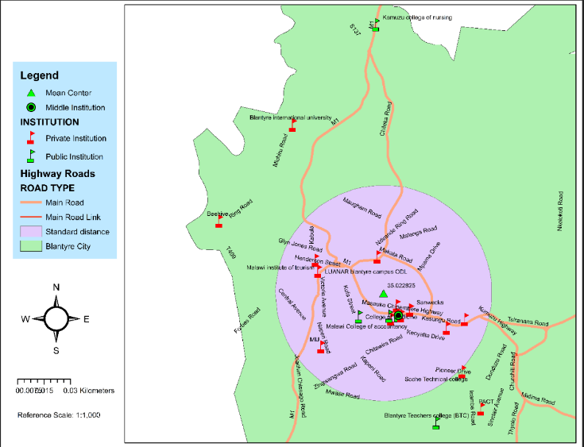

Figure 3 Spatial map

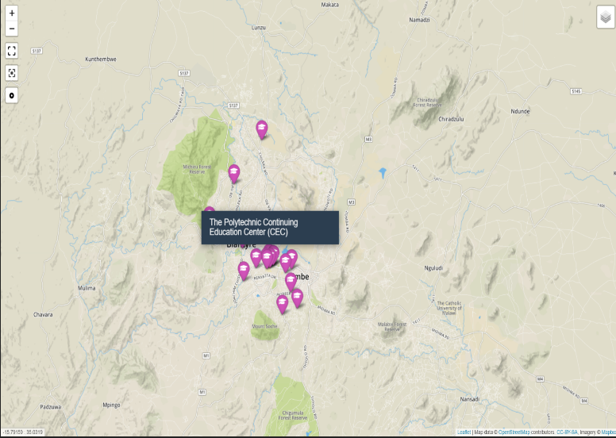

Figure 4 web deployed map

To deploy the map to the web for public use by the public users, the institutions layer was exported to geojson data and was overlaid on open street map layers retrieved from [mapbox](htttp://mapbox.com). The initial requirements wanted for users to be able to interact with the map and dynamically get information on selected institution. A web deployment of the map was best achieved by use of web technologies as discussed in the next section. An HTML page was constructed and the leaflet library API was used to overlay the institutions with markers. This page was hosted on a regular web server.

## 4.2 Technologies

The core technologies that were used in the production of the map and development of the application are:

### ArcGIS

This was the primary software that was use for the map production and spatial analysis. Using the spatial statistics tools the team was able to analyze and measure the geographic distribution of features for the Tertiary institutions feature class.

### QGIS

The web application required the data layer to be in a geojson format but the primary software, ArcGIS did not have this feature. Using QGIS the shapefile of the Tertiary institution layer was easily converted to geojson. This is the only functionality why QGIS was used as a technology for the project.

### Leaflet

Leaflet is an open-source JavaScript library for mobile-friendly interactive maps. Using the geojson data of the tertiary institutions, the team was able to overlay it on 2 open street map tile layers retrieved from mapbox. The team used other plugins such as layer switcher to enable the user switch base layers between street layer or satellite layer.

## 4.3 Technology Limitations

They were a few technical limitations encountered that caused the team unable to implement some of the functionalities specified in the requirements specification such as being able to inform the distance to the various institutions with the user as the landmark. The limitations encountered include:

* Inadequate technical knowledge of leaflet to implement necessary functionality
* Inadequate knowledge of ArcGIS to perform other spatial analysis
* Technical resources to run a geoserver for dynamically managing the layer data for the web application as earlier required.

## 4.4 Spatial Analysis

The team was interested in measuring the geographic distribution of the institutions and hence utilized the Spatial statistic tools in ArcGIS. Specifically, the following analysis was made.

### Central Feature

The team wanted to identify the centrally location feature in the institutions feature class. From the analysis, it was discovered that **Malawi College of Health Science** is the most centrally located education institution in Blantyre.

### Mean Center

Using this measure, the team was able to identify the geographic center of the institutions. This was found to be at Longitude **35.022825**.

### Standard Distance

The team wanted to measure the degree to which the institutions are concentrated or dispersed around the geometric mean center. It was revealed that quite a number of institutions were clustered around the mean center. The area of standard distance is illustrated in application screenshots figure 9.

### Directional Distribution

The team wanted to analyze the directional trend of institutions from the mean center. The result is illustrated by figure 10 under application screenshots.

## 4.4 Application Screenshots

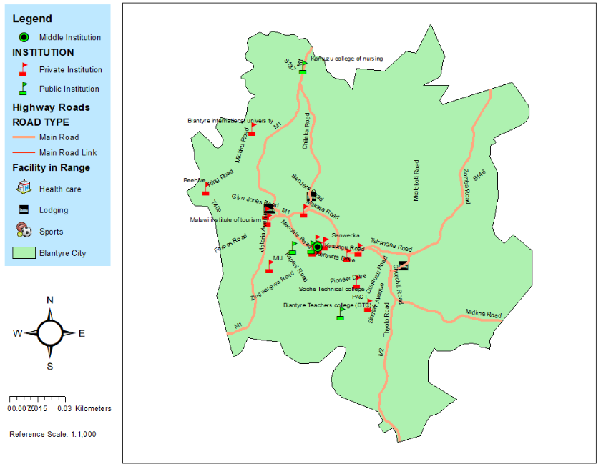

Figure 5 BHEI map - full extent

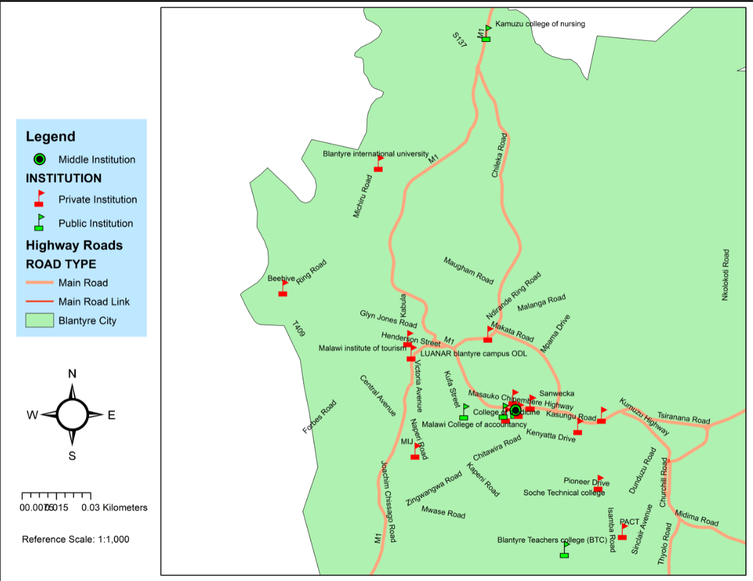

Figure 6 BHEI map - target institutions extent

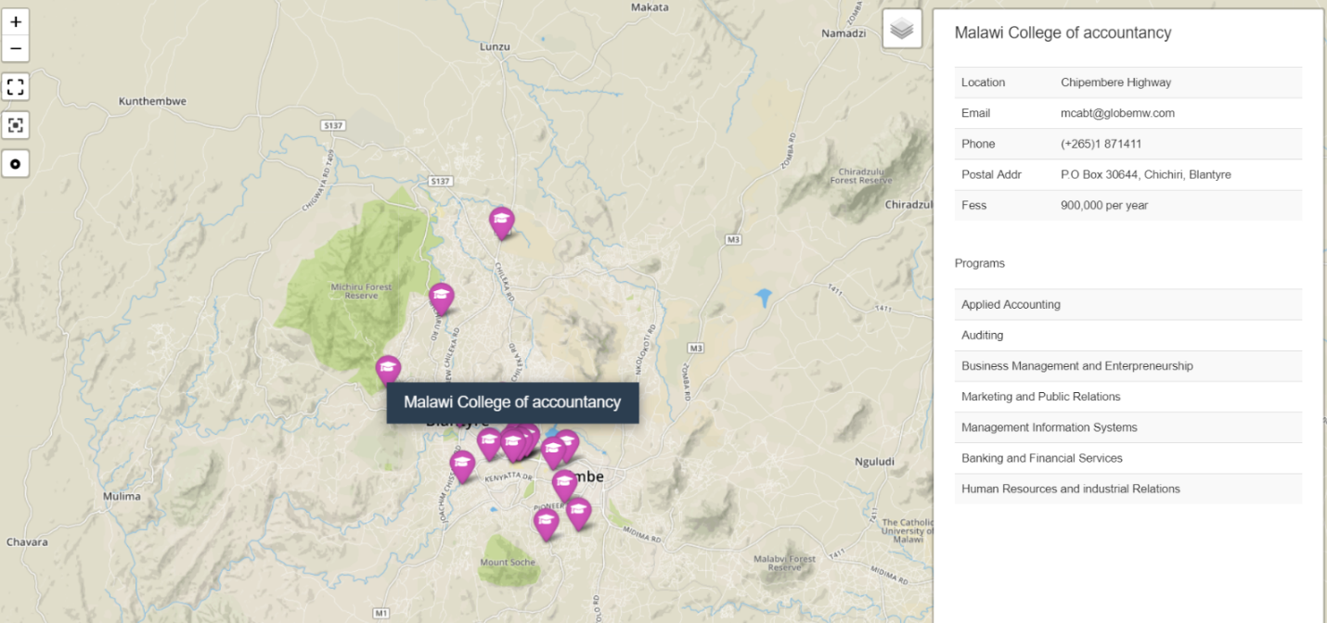

Figure 7 BHEI web application map with information sidebar

When the user clicks on the marker of the institution, a sidebar opens up with information about the target institution such as location, contact details, fees and list of programs.

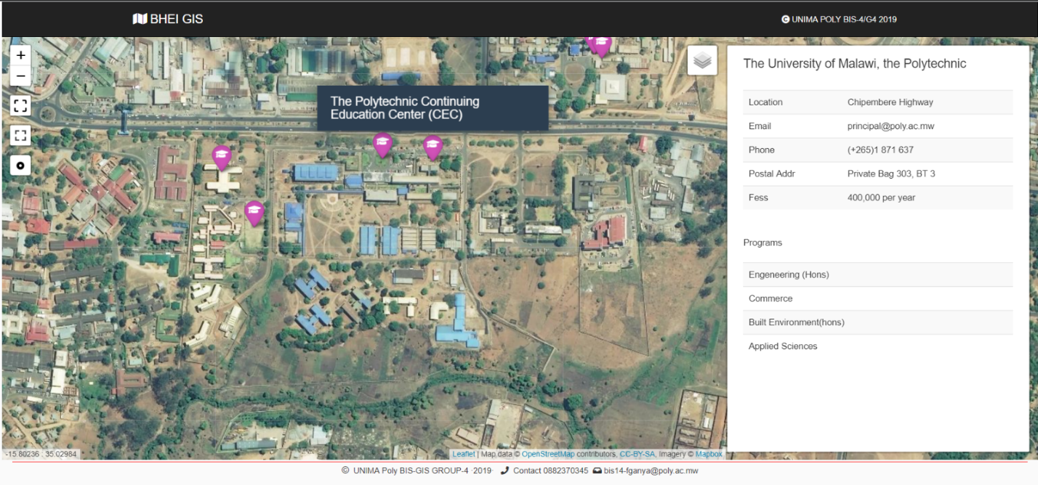

Figure 8 BHEI map Satellite view - UNIMA poly sample

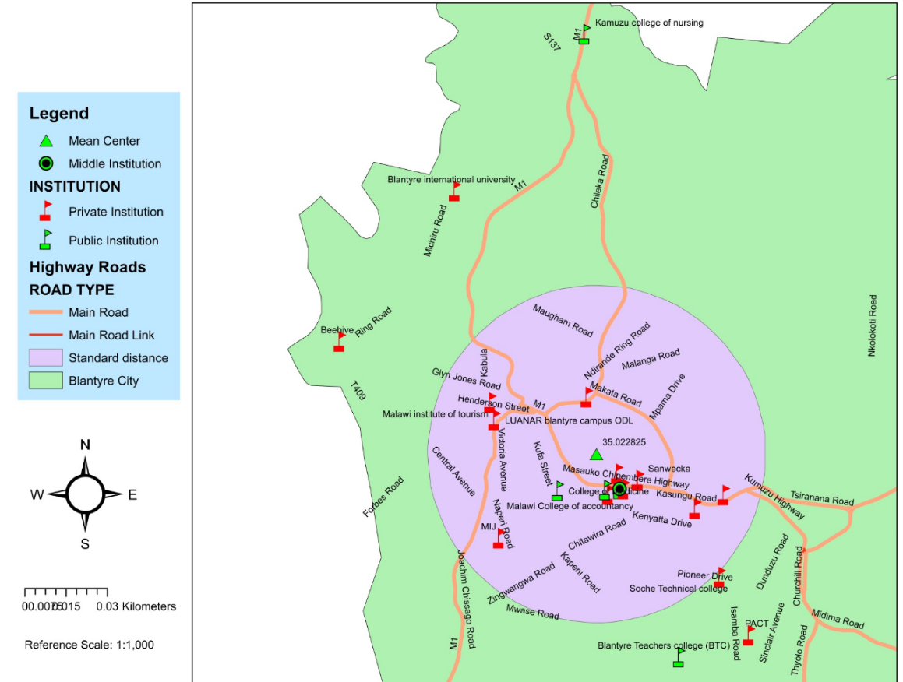

Figure 9 BHEI map - standard distance geographic distribution

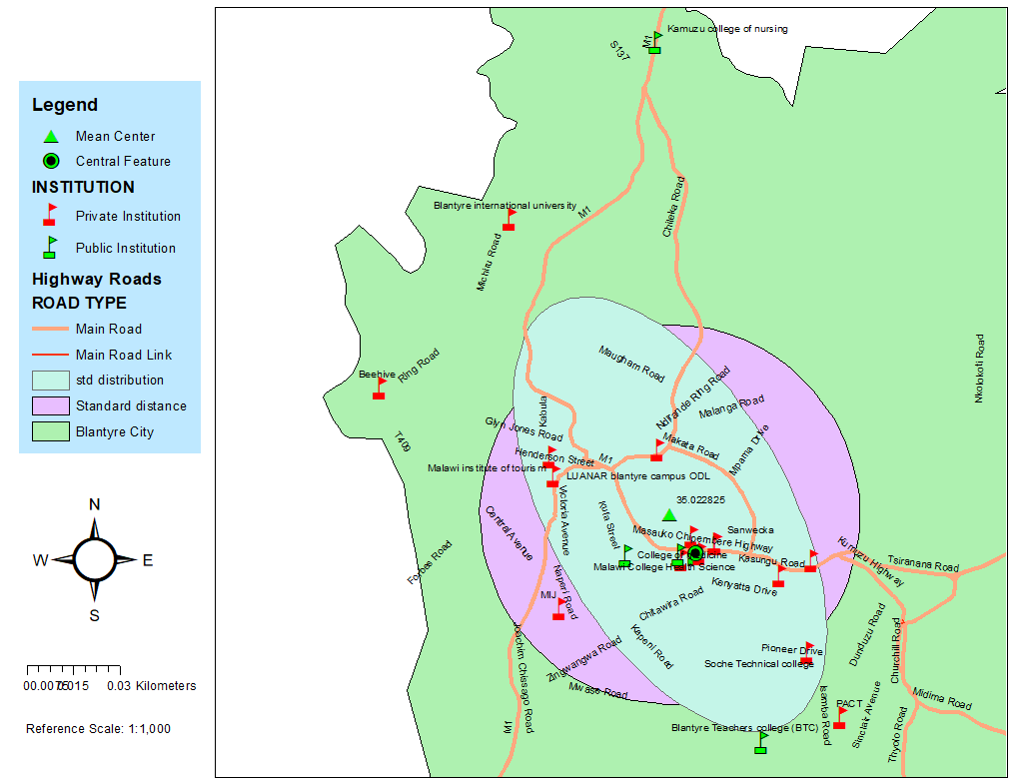

Figure 10 BHEI map - directional distance geo distribution

# 5.0 Team Members Individual Reflections

## Francis Ganya

This exercise has been one exciting and very challenging journey for me. It was very exciting to realize the possibilities that could be achieved with GIS and how much information could be portrayed by GIS. The challenging part was learning the technologies themselves especially identifying the tools that were more suited for what you were tying to achieve and how to use them. All in all, having tackled this exercise I am personally confident to use GIS as an application as well as engage in the bigger discussion of the development of geographic information systems.

## Abigail Mwale

Geographic Information Systems project has helped me explore more than what I expected to gain at the end of the module. I really appreciate the criteria the lecture used to help us explore and appreciate the power of GIS.

I have learnt how to map selected features using ArcGIS application, a project that has made me explore more on how to utilize the application more than the class lecture. With this, I have learnt new technologies like the use of leaflet, for building web-mapping application, a task that would have been hard to use and understand alone.

The challenges encountered during the project are of not finding the coordinates on the google map for some tertiary institutions like Sanwecka and as well as finding different coordinates for one institution of which the solution was to choose one coordinate, a thing that has further created a problem in locating one university on a wrong site, Blantyre International University.

We have been struggling to map the institutions, until realization of leaflet application, which gave a way to go, a challenge that helped us explore more through research enhancing the technical expertise of mapping locations

Lastly, I thank my fellow group members for coordination during all these two projects, especially those who had knowledge on the unfamiliar technologies, who had to put extra effort helping the rest of us understand and follow what was happening for every member to gain ideas equally. This has really added my skills of research and technical approach of solving GIS problem

## Angella Kamera

Geographical Information System (GIS) has been an interesting module to learn how to capture data, map the data. I have learnt a lot throughout this project. For example, how to use ArcGIS to create maps. GIS technologies allows us to use satellite data to show a variety of information about a specific location. Like in our group we were mapping Tertiary Education Institution, this map shows the courses offered at the colleges, approximate fees structure, contact details which can will help to reduce costs and time to travel around to compare fees and courses offered at different colleges here in Blantyre city.

Working as a team has also made me to explore more on how GIS technologies are used and use leaflet application which I didn’t knew nothing about and it has a been a wonderful experience to use Leaflet application which has all mapping features most developers need. And also, as a team we solved difficult problems faster because we shared ideas and every decision was first evaluated then implement it and come up with creative ways of doing things.

**Challenges faced**

* We did not have GPS machine to use to collect the coordinates which has resulted in having wrong coordinates for Blantyre International University and it has ended up in locating the college in a wrong site.
* At first, we didn’t know how to use ArcGIS software but now we have learnt how to use it.

This group project has also helped me to have a clear understanding of what Geographical Information System is all about and how to use ArcGIS. I believe that the knowledge I have gained in this project will be very useful and I will apply it in every future GIS project.

## Before Ndakwera

This project gave me an opportunity to have a hands-on experience on the application and development of geographical information systems. I now have the knowledge to create maps and perform spatial analysis on them and even deploy them to the web. This experience was very good for my skills development in GIS.

# 6.0 Conclusion

Presented in this document was an exhaustive report of the project activities that a group of BIS final year student undertook to design and implement a mapping application for Blantyre Higher Education institutions to ease retrieval of information by school leavers. The core technologies that were used in the project were ArcGIS, QGIS and Leaflet open source library for making maps.